LaB2 Environmental Issues Scan
Part 1: Screening Analysis

Table 1. Chart of Environmental Scan (see Captivate Presentation for an example of how to complete this chart)

Environmental Scan
Issue  (List the issue) | Details  (Fill in information on the site, extent, land use type where you identified the issue, etc.) | Impacts and Implications  (Provide notes on following: are the impacts small or large in scope, significant or insignificant, why?, who is affected? Scale issues?) | Resolution  (How can this issue be addressed? What resources are required ($, human)? Is it feasible to resolve? Why has it not been resolved?)
Noise pollution | Found the building construction close to my apartment(Phillip street), construction noise significantly. | The impact of noise pollution is large in scope due to the vast amount of people live here. This is a very significant issue because the construction noise generates unwanted sound judged to be loud and disruptive to hear. The people who lived here and the people who walked through would all be affected by the noise pollution. | Noise pollution can be reduced through carefully handing equipment and the use of quiet materials. Also, the building worker should reasonably arrange the time of construction. To work in the daytime as much as possible instead of night work. To purchase the low-noise equipment needs money.
Air pollution | The major source of air pollution is the dust from the building construction which is located around my apartment. Dust has a large spread through air into humans. | The air pollution impact is very large in scope since the swirl of construction dust release every day. It becomes a significant issue that needs to take this problem into consideration right away. Those affected are residents, vegetation and animals. Dust particles are stirred up into the air. Air pollution can negatively affect humans through their breath and absorb into the skin. | The water tanker can be used in preventing dust from airborne. This is the most used alternative due to the effective cost and its excellent result. This approach requires a driver to drive the water tanker but also needs a small amount of money to make it work. Moreover, the residents better to reduce the use amount of opening windows, so it would reduce the dust indoor.
Habitat destruction to create housing and commercial estate | Due to the development of Waterloo city and the improvement of residential demand, more houses and business buildings are being built. The area of parks become much smaller. That means a significant loss on natural habitat & land. | Habitat destruction seems to have a large in scope impact. A majority of natural lands are destroyed for buildings. The removal of trees and vegetation will contribute to global warming and climate change. Because the more trees cut down, the more greenhouse gases go into the air which cause the temperature goes up. As the loss of natural land, the wildlife is no longer have the natural shelter. | Through public activities that report habitat destruction, a significant awareness of the issue from the public. So more people would take actions to preserve the habitat. Also, we can reduce our over-consumption needs, limiting waste from natural land. To deal with this issue, people are required to learn more about habitat loss, and help to educate and influence others about the importance of reducing the use of land.
Throwing rubbish | On my walk to my school, I always can find the garbage be thrown on the street. Especially the locations on the two Plazas which have lots of restaurants and shop stores. | This issue seems small in scope but in fact it is a large issue that throwing rubbish is a negative behavior and an increasing amount of trash can cause many dangers. Not only does give negative impact for human health, especially for people who have low immune system like elders, kids and pregnant women. Those people would cause infection and chronic diseases because of the release of rubbish. | The government can increase the amount of garbage can on the street or on the community which requires money to support. So people would have more chances to throw rubbish to the garbage can. Or the government can announce a new program which is called “Pay for your behavior”. People who throw rubbish would be charged, the result of this program would decrease a large amount of garbage be thrown anywhere.
Car emissions | There are always cars being driven whatever the location is, and emit a wide range of harmful gases into the atmosphere. | The impact of car emission is large in scope due to the vast amount of vehicles exhaust to the environment. This is a significant issue since greenhouse gases and chemicals being emitted to the air. Car pollutants harm human health, especially its impact human lung function, which causes chest pain, coughing and make people difficult to breathe. | The government can limit the amount of vehicles for each family. And encourage people to take public transportations as much as possible. But this resolution is not easy to resolve since people can save much more time for driving a car and free to go wherever they want.

Provide a brief summary of the path you took and the areas around the campus you examined. Create a map and highlight your route. You can choose to use google maps to create your map: (see Lab Cast Presentation). Ensure that you note observations on the map and also document issues if possible with photos.

The route I took which is from 256 Phillip Street (my home) to 75 University Ave W (WLU). This route took my 15 minutes to walk to the school every day. The streets I passed were Phillip Street – Sunview Street – Albert Street – Bricker Avenue. On the way to my walk, I found five areas where existing environmental issues. Fergus House is a construction building which is located on Phillip Street in front of my apartment. This building causes noise and air-related environmental problems. Also, the two Plazas in University Avenue which were filled with lots of rubbish. On the Albert Street, natural lands were used to build residential apartments. Moreover, on my walk I always say cars being driven and emitting harmful gasses into the air.

Map:
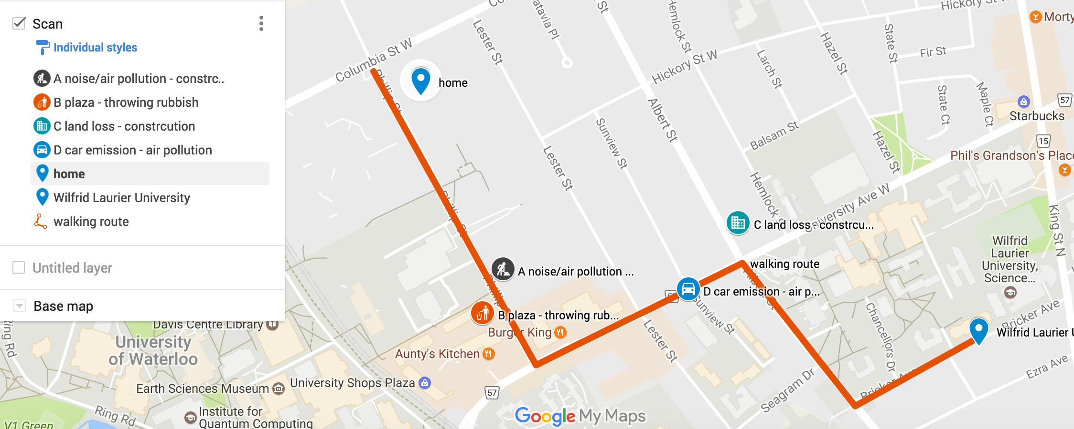

Photos:
A: Noise / Air pollution (Construction noise / Construction dust)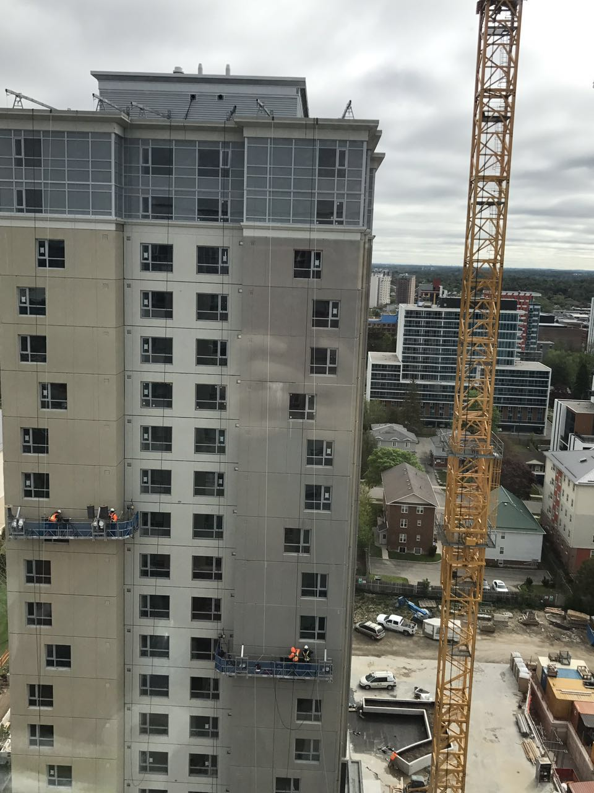

B: Throwing rubbish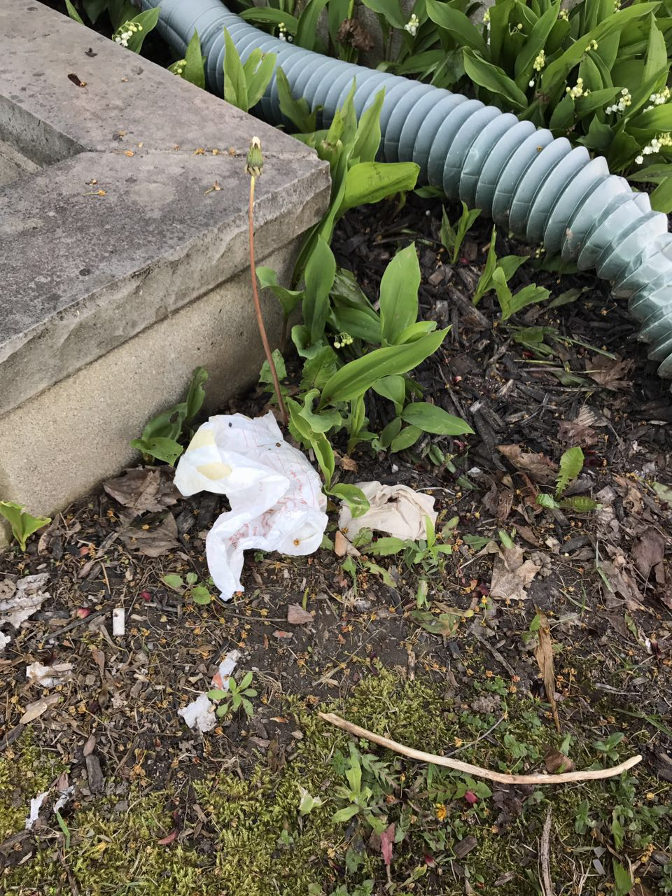

C: Land loss/ Habitat destruction 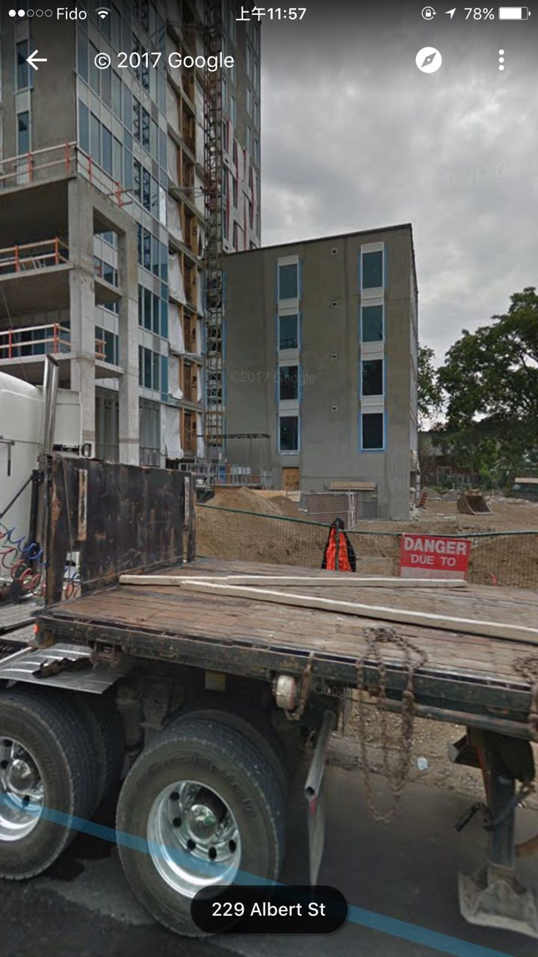
D: Car emission 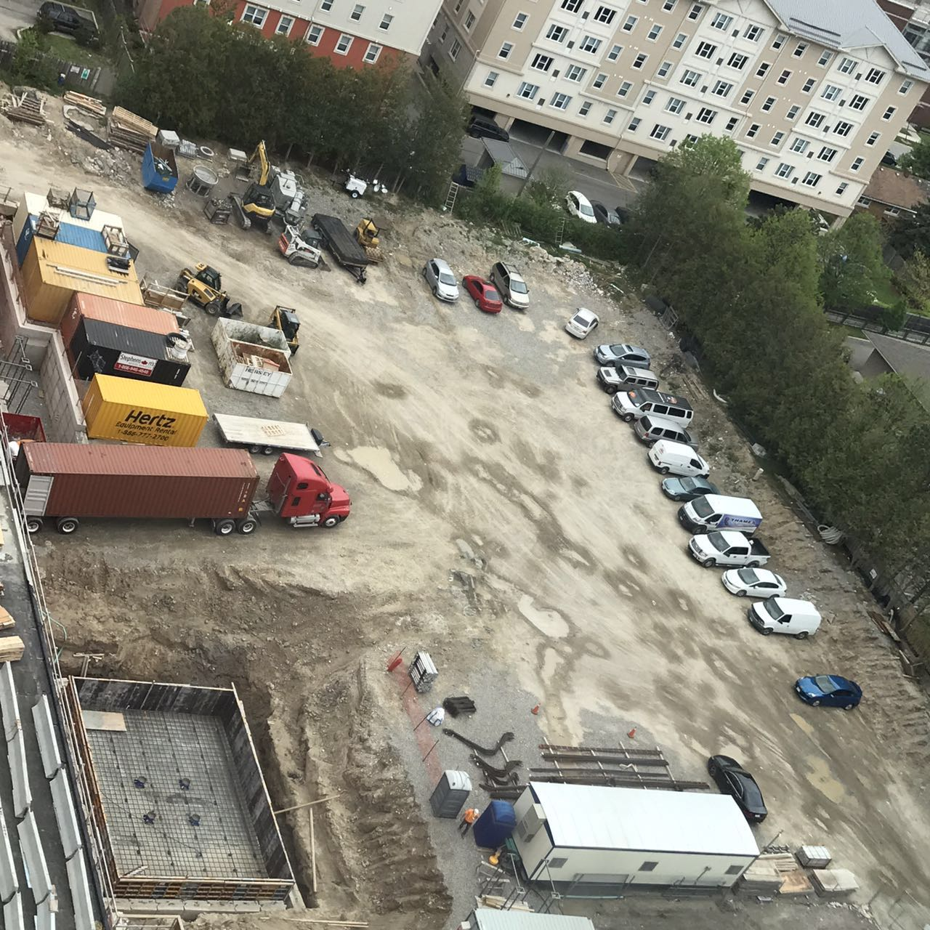

Part 2: Results and Discussion - Key Issues Assessment (maximum 1-1.5 pages – single spaced)
1. Which do you think are the three most important issues? In your response, rank all of your issues and briefly explain your rationale for the ranking of the top three issues.

From my perspective, I believe that the three most important issues would be: (1) Air pollution (2) Car emissions (3) Habitat destruction. The reason why I gave these rankings because these three factors play a crucial rule to human life. With the more buildings being built, the dust pollution has been spread through the air to humans. People are affected by breathing and absorbing into their skin. Especially for people with low immune system at increased risk from air pollution. The quality air is an essential part for people to survive and live well. The same goes for car emission, car exhausts emit harmful chemicals and greenhouse gases, which causing global warming and negatively impact the environment and human health. Finally, habitat destruction also causes a harmful influence occurs by loss on lands. A vast majority of trees are cut down for human homes and commercial buildings. The more greenhouse gases are generated and wildlife no longer have natural shelter to live. All of these three issues are large in scope and interconnect to our environment.

2. Would you consider these three issues relatively major or minor? Why?

These three issues definitely consider as major issues. Based all the explanations I presented above. They are essential to human life and sustain them to survive. Also, these three issues are relatively significant to the nature of ecosystem.

3. How do these three issues you identified relate to problems of population, lifestyles and consumption, and/or our societies desire for economic growth and expansion? In what way?
These three issues relate to problem of population because they can directly impact people’s health. Through air pollution, car emission and habitat destruction, these would decrease the population which make people suffer disease and even cause death. With air pollution and harmful chemicals of car emission, the dust from construction and greenhouse gases are generated into people’s lung. Breathing polluted air cause you at a higher risk for asthma and other respiratory diseases as well as lower your life expectation. Also, since the dust cause air pollution and cars emit carbon dioxide, people would reduce outdoor activities and reduce the use amount of opening windows. Their lifestyles can be changed a lot different due to these issues. For the consumption changes, people would increase the purchase of dust masks to prevent air pollution. On the other hand, people would better take the public transportations rather than private vehicles.

4. Are the issues a local scale issue, or are they connected across scales in some way (economically, ecologically)?

These issues are connected across scales both economically and ecologically. They are common and worldwide. All places around there are vast amount of vehicles emitting carbon dioxide into the atmosphere, construction buildings generate dust which stirred up into the air. And wildlife be harmed when their natural habitats has been used to construct human homes. These issues are carried through wind, air, waste. (Need to be fixed)

Part 3: Conclusions and Recommendations (maximum ½ page)

Based on your assessment above, what do you think the Environmental Services Department could do to address or alleviate the situation? Offer some concrete (and feasible) recommendations for change.

